**Noughts and Crosses**

The game is based on the concept of the original "Noughts and Crosses" mechanics. Besides, the use of dice is the deciding factor in the game's turn and the element of luck that players get. It involves citing situations such as resuming the move, passing the turn to an opponent, stopping a turn, or having a special task. Players can go Noughts or Crosses first and they must have different colors to distinguish them. Each turn the player will fill in the space between the intersections. Your goal is to come up with strategies and pathways so that the opponent has no choice. Materials that create them include paper containing squares and dice to drop.

Mechanisms and rules:

The roll of the dice determines the player's move. However, players will have to depend on luck for each roll of the dice. Therefore, creating tension between players is a necessary factor and increases the drama. Furthermore, devising a strategy for each move to gain an advantage and achieve the ultimate goal. Besides, this new mechanism also allows players to swap or lose their turns for other players. The winner is the person who has a continuous sequence of 4 consecutive positions including horizontal, vertical, or diagonal if not blocked. If the head is blocked, there must be 5 consecutive positions to win. Also, if 2 ends are blocked, even 5 consecutive positions will not be counted as a victory and the game will continue.

The player can choose to go before and after and can optionally choose any position on the empty slot. After releasing the dice, if there are dots 1, 2, or 3, you are allowed to select any one box on the empty box. If it is 4 then you have to delete one of your positions. Point 5 means you lose turns and dot 6 means you can switch positions of the opponent. The winner will be the winner of the 3 lanes with 5 consecutive positions and not being blocked by 2 heads.

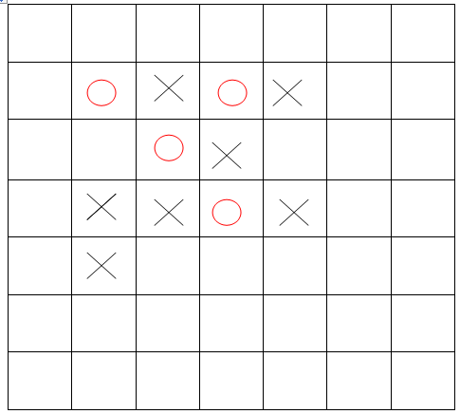

Winning image with 4 consecutive positions if not locked at the top

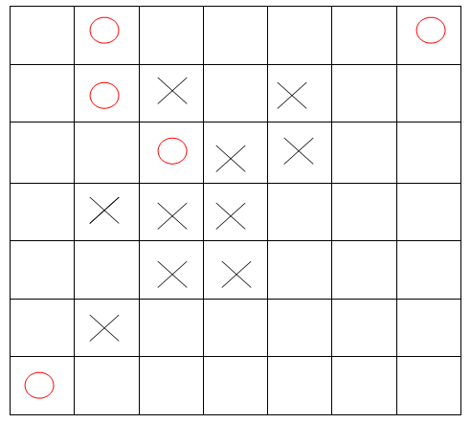

Positions of points are not recognized if there are 2 blocking points at the start at Crosses

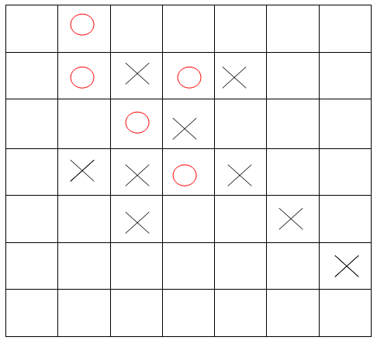

Position 5 points in a row when there is a stop at the start at Crossess

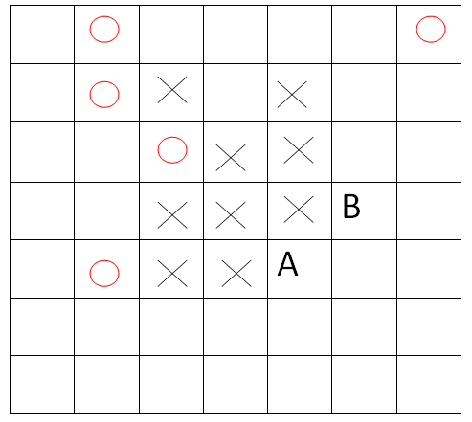

Come up with a good strategy in A or B to win

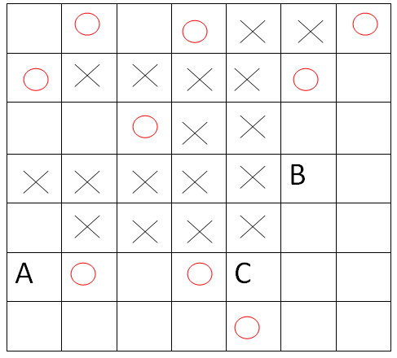

Position of points A B C illustrates the winner in the end

When starting the tests and trial play, there is no number of swaps of the opponent's positions. Mostly, you can go to anyone slot or lose your turn. Therefore, it is difficult to be the final winner if it has to reach 3 consecutive positions in a game.

Experience in problem-solving:

When it comes to giving idea steps and conducting experiments, it can be difficult to give clear captions to help players understand the rules of the game and come up with a specific strategy. Moreover, playing and explaining each specific situation will be the best way for players to visualize the rules of the game. However, from the start of contributing ideas and giving the appropriate laws to persuade team members to implement, it is difficult because new team members have their thoughts. The difficulty here is how to persuade and make assumptions? that prove one's ideas are the most plausible. On the other hand, contributing ideas and building them into a logic game rules system is essential for the members. Through this, when doing group implementation sessions, it helped me to understand problems in contributing ideas and develop them into a common idea. Patience and perseverance will help me to overcome difficulties and challenges.

List of experimental players: Hou Yuen Yap, Will Connel.

References:

Caro (2020) *Cờ Caro Online*. Available from: https://www.playcaro.com/ [Accessed 15 November 2020].

Renju (2020) *The Renju International Federation portal - RenjuNet*. Available from: http://www.renju.net/ [Accessed 15 November 2020].